Student Name: Anirudh Kumar  
Email: akuma282@asu.edu  
Submission Date: October 23, 2022  
Class Name and Term: CSE548 Fall 2022

Project Title

# Project Overview

We explore how a packet filter firewall works using two Linux virtual machines a working one and a dual homes Gateway client to access external networks on o ne interface and then setup as a client which can only access external networks through the gateway. The gateway is configured with the Linux IP tables firewall and also enable NAT for selected protocols. The lab setups a web server on Gateway with a test web page. We test having full control of network traffic, specific protocls for specific destinations and modifying specific parameters in the firewall script.

# Network Setup

VM configures itself through a default gateway, bypasses the gateway VM, and uses virtualBox DHCP server

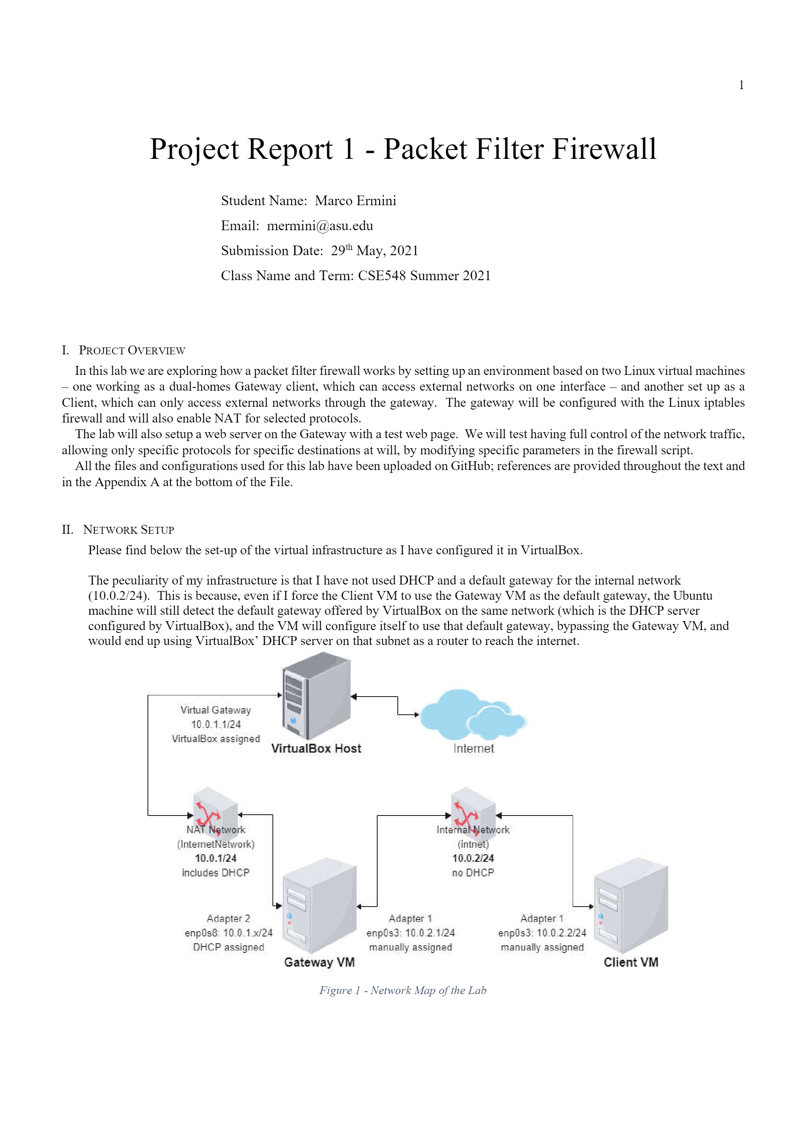

In my setup, the gateway forces the path as the only possible gateway. DHCP is disabled in the internal network and manually configured the Ips on the internal interface of the Gateway VM and Client VM. Client VM passes the Gateway VM for external rechabilility.

Overall initial configuration looks like :

|  |  |  |  |
| --- | --- | --- | --- |
| IP Address | 10.0.2.x/24 (DHCP) | 10.0.1.1/24 | 10.0.2.2/24 |
| Gateway | On interface | Adapter 1 | 10.0.2.1 |
| Initial Reachability | Internet via VirtualBox | Client VM IP | Gateway adapter 2 IP |
|  |  |  |  |

Ubuntu’s 18.04 LTS version configures network interfaces through applciations, Its configuration scripts areeY YAML files NetPlan is configured to use NetworkManager to handle IP addresses You manually assign IP addresses and configure the DHCP.

On the gateway:

root@ubuntu:/etc/netplan# cat 02-gateway-networks.yaml

*network:*

*renderer: networkd*

*version: 2*

*ethernets:*

*enp0s3:*

*addresses: [10.0.2.1/24]*

*#gateway4: 10.0.2.1*

*dhcp4: no*

*dhcp6: no*

*nameservers:*

*addresses: [208.67.222.222,208.67.220.222]*

*enp0s8:*

*addresses: []*

*#gateway4: 10.0.2.1*

*dhcp4: yes*

*dhcp6: no*

*nameservers:*

*addresses: [208.67.222.222,208.67.220.220]*

root@ubuntu:/etc/netplan#

On the client:

root@ubuntu:/etc/netplan# cat 02-internal-network.yaml

*network:*

*renderer: networkd*

*version: 2*

*ethernets:*

*enp0s3:*

*addresses: [10.0.2.2/24]*

*gateway4: 10.0.2.1*

*dhcp4: no*

*dhcp6: no*

*nameservers:*

*addresses: [208.67.222.222,208.67.220.220]*

root@ubuntu:/etc/netplan#

On VirtualBox, the two internal networks were configured as it follows: via the Preferences menu, select “Network”.



Fig 2 : VirtualBox Preferences



Figure 3 : VirtualBox Networks Configuration

Then click the + button and configure the NatNetwork :



Figure 4 : Internet Network Configuration



Figure 5 : NatNetwork Configuration



Gateway Adapter 2 on VirtualBox



Gateway Adapter 1 on Virtual Box



Client Adapter Configuration



VM Interface in Linux



VM interface in Linux



Gateway VM initial forward routing and iptables



Client VM Initial network situation



Client Routing table



Initial Gateway internet connection



Gateway initial routing table

# Software

Software used include : network tools, Linux’s built in packet forwarding router, built-in packet nspection and NAT firewall, iptables

# Project Description

The following are the stages that need to be completed you paste the commands listed below for the initial configuration :

Initial setup and connectivity testing : See the network setup

Then from the terminal window on gateway, check internet reachability

ubuntu@ubuntu:~$ ping cisco.com

*PING cisco.com (72.163.4.185) 56(84) bytes of data.*

*64 bytes from cisco.com (72.163.4.185): icmp_seq=1 ttl=239 time=147 ms*

*64 bytes from cisco.com (72.163.4.185): icmp_seq=2 ttl=239 time=156 ms*

^C

*--- cisco.com ping statistics ---*

*3 packets transmitted, 3 received, 0% packet loss, time 2002ms*

*rtt min/avg/max/mdev = 144.485/149.644/156.627/5.141 ms*

ubuntu@ubuntu:~$ dig google.com

*; <<>> DiG 9.11.3-1ubuntu1.15-Ubuntu <<>> google.com*

*;; global options: +cmd*

*;; Got answer:*

*;; ->>HEADER<<- opcode: QUERY, status: NOERROR, id: 16376*

*;; flags: qr rd ra; QUERY: 1, ANSWER: 1, AUTHORITY: 0, ADDITIONAL: 1*

*;; OPT PSEUDOSECTION:*

*; EDNS: version: 0, flags:; udp: 65494*

*;; QUESTION SECTION:*

*;google.com. IN A*

*;; ANSWER SECTION:*

*google.com. 108 IN A 216.58.206.78*

*;; Query time: 0 msec*

*;; SERVER: 127.0.0.53#53(127.0.0.53)*

*;; WHEN: Sat May 29 15:24:17 MST 2021*

*;; MSG SIZE rcvd: 55*

ubuntu@ubuntu:~$

7

Please note that response times and latency will vary.

*Figure*



Issuing the command ping after gateway is completed is done as follows :

ubuntu@ubuntu:~$ ping 10.0.2.2

*PING 10.0.2.2 (10.0.2.2) 56(84) bytes of data.*

*64 bytes from 10.0.2.2: icmp_seq=1 ttl=64 time=0.394 ms*

*64 bytes from 10.0.2.2: icmp_seq=2 ttl=64 time=0.373 ms*

*64 bytes from 10.0.2.2: icmp_seq=3 ttl=64 time=0.433 ms*

^C

*--- 10.0.2.2 ping statistics ---*

*3 packets transmitted, 3 received, 0% packet loss, time 2052ms*

*rtt min/avg/max/mdev = 0.373/0.400/0.433/0.024 ms*

ubuntu@ubuntu:~$

We have already verified on the Network Setup chapter, that there is no forwarding nor iptables rules enabled on the Gateway

right now. No further demonstration is necessary, but at will, further commands can be run:

ubuntu@ubuntu:~$ sudo iptables -L -v -n

*[sudo] password for ubuntu:* 123456

*Chain INPUT (policy ACCEPT 256 packets, 24309 bytes)*

*pkts bytes target prot opt in out source destination*

*Chain FORWARD (policy ACCEPT 0 packets, 0 bytes)*

*pkts bytes target prot opt in out source destination*

*Chain OUTPUT (policy ACCEPT 435 packets, 30539 bytes)*

*pkts bytes target prot opt in out source destination*

ubuntu@ubuntu:~$ route -nv

*Kernel IP routing table*

*Destination Gateway Genmask Flags Metric Ref Use Iface*

8

*0.0.0.0 10.0.1.1 0.0.0.0 UG 100 0 0 enp0s8*

*10.0.1.0 0.0.0.0 255.255.255.0 U 0 0 0 enp0s8*

*10.0.1.1 0.0.0.0 255.255.255.255 UH 100 0 0 enp0s8*

*10.0.2.0 0.0.0.0 255.255.255.0 U 0 0 0 enp0s3*

ubuntu@ubuntu:~$ ip addr

*1: lo: <LOOPBACK,UP,LOWER_UP> mtu 65536 qdisc noqueue state UNKNOWN group default qlen 1000*

*link/loopback 00:00:00:00:00:00 brd 00:00:00:00:00:00*

*inet 127.0.0.1/8 scope host lo*

*valid_lft forever preferred_lft forever*

*inet6 ::1/128 scope host*

*valid_lft forever preferred_lft forever*

*2: enp0s3: <BROADCAST,MULTICAST,UP,LOWER_UP> mtu 1500 qdisc fq_codel state UP group default qlen 1000*

*link/ether 08:00:27:6d:f6:f9 brd ff:ff:ff:ff:ff:ff*

*inet 10.0.2.1/24 brd 10.0.2.255 scope global enp0s3*

*valid_lft forever preferred_lft forever*

*inet6 fe80::bb19:9ce2:253b:7920/64 scope link noprefixroute*

*valid_lft forever preferred_lft forever*

*3: enp0s8: <BROADCAST,MULTICAST,UP,LOWER_UP> mtu 1500 qdisc fq_codel state UP group default qlen 1000*

*link/ether 08:00:27:82:de:07 brd ff:ff:ff:ff:ff:ff*

*inet 10.0.1.5/24 brd 10.0.1.255 scope global dynamic enp0s8*

*valid_lft 514sec preferred_lft 514sec*

*inet6 fe80::b93e:c713:21d2:5726/64 scope link noprefixroute*

*valid_lft forever preferred_lft forever*

ubuntu@ubuntu:~$

Enabling Linux kernels package it is necessary for configuration parameter :

$ sudo sysctl -w net.ipv4.ip_forward=1

or

$ echo 1 | sudo tee /proc/sys/net/ipv4/ip_forward

Using “cat” to print the value of the parameter will verify it is set correctly.

ubuntu@ubuntu:~$ cat /proc/sys/net/ipv4/ip_forward

*1*



We don’t need to configure default routes We test if the client can reach the gateway.

ubuntu@ubuntu:~$ route -nv

*Kernel IP routing table*

*Destination Gateway Genmask Flags Metric Ref Use Iface*

*0.0.0.0 10.0.2.1 0.0.0.0 UG 0 0 0 enp0s3*

*10.0.2.0 0.0.0.0 255.255.255.0 U 0 0 0 enp0s3*

9

ubuntu@ubuntu:~$ ping 10.0.2.1

*PING 10.0.2.1 (10.0.2.1) 56(84) bytes of data.*

*64 bytes from 10.0.2.1: icmp_seq=1 ttl=64 time=0.427 ms*

*64 bytes from 10.0.2.1: icmp_seq=2 ttl=64 time=0.400 ms*

*64 bytes from 10.0.2.1: icmp_seq=3 ttl=64 time=0.379 ms*

*^C*

*--- 10.0.2.1 ping statistics ---*

*3 packets transmitted, 3 received, 0% packet loss, time 2028ms*

*rtt min/avg/max/mdev = 0.379/0.402/0.427/0.019 ms*

ubuntu@ubuntu:~$



Routing on Client

Cnanot ping beyond gateway :

ubuntu@ubuntu:~$ ping 8.8.8.8

*PING 8.8.8.8 (8.8.8.8) 56(84) bytes of data.*

(after circa four seconds…)

^C

*--- 8.8.8.8 ping statistics ---*

*5 packets transmitted, 0 received, 100% packet loss, time 4085ms*

ubuntu@ubuntu:~$

Enable NAT rules on Gateway and allow ability to reach the Internet

ubuntu@ubuntu:~$ sudo -i

*[sudo] password for ubuntu:* 123456

root@ubuntu:~# iptables -P FORWARD ACCEPT

root@ubuntu:~# iptables -t nat -A POSTROUTING -o enp0s8 -j MASQUERADE

root@ubuntu:~# iptables -t nat -L POSTROUTING -n -v --line-number

*Chain POSTROUTING (policy ACCEPT 0 packets, 0 bytes)*

*num pkts bytes target prot opt in out source destination*

*1 0 0 MASQUERADE all -- * enp0s8 0.0.0.0/0 0.0.0.0/0*

root@ubuntu:~# 

LAZY NAT Configuration



Able to receive Internet ppings connect to internet address

F. Install software in Linux





Update installed packages



Install tcpdump on Gateway



Install apache2 on gateway

H. Setup Apache2

*<VirtualHost *:80>*

*ServerName test-and-demo.com*

*ServerAlias *.test-and-demo.com*

*ServerAdmin mermini@asu.edu*

*DocumentRoot /var/www/test/html*

*ErrorLog ${APACHE_LOG_DIR}/error.log*

*CustomLog ${APACHE_LOG_DIR}/access.log combined*

*</VirtualHost>*

The next configuration file to change is “/etc/apache2/ports.conf”, which needs to be set as the followings:

*Listen 127.0.0.1:80*

*Listen 10.0.2.1:80*



Adding Host Name :

Create now a file called “index.html” to be positioned in the current folder and fill it with the content below.

<html>

<head>

<title>ASU rocks!</title>

</head>

<body>

<p>This website is running on an Ubuntu Server from an ASU lab!</p>

<p>Contact the admin at <a href="mailto:akuma282@asu.edu">akuma282@asu.edu</a> for questions</p>

</body>

</html>

Is the Apache Client Reachable :

ubuntu@ubuntu:~$ sudo -i

*[sudo] password for ubuntu:* 123456

root@ubuntu:~# echo "10.0.2.1 www.test-and-demo.com" >> /etc/hosts

root@ubuntu:~# cat /etc/hosts

*127.0.0.1 localhost*

*127.0.1.1 ubuntu*

*# The following lines are desirable for IPv6 capable hosts*

*::1 ip6-localhost ip6-loopback*

*fe00::0 ip6-localnet*

*ff00::0 ip6-mcastprefix*

*ff02::1 ip6-allnodes*

*ff02::2 ip6-allrouters*

*10.0.2.1 www.test-and-demo.com*

root@ubuntu:~#





Running rc.sh script

After running script, gateway is configured to filter certain ports and block others.

Source Destination Protocol Rule Comment

Client Gateway TCP/80 Allowed Reach the Web Server on the Gateway

Client Internet TCP/80 Allowed Reach Web for updates

Client Internet TCP/443 Allowed Reach Web for updates

Client DNS servers ICMP Allowed Ping DNS servers

Client DNS servers DNS Allowed Allow DNS resolution

Client Gateway ICMP Allowed Ping the Gateway

Client 8.8.8.8 ICMP Allowed Ping Google DNS

Client * * Deny Deny the rest

Gateway Loopback * Allowed Allow loopback

Gateway Client ICMP Allowed Ping the Client

Gateway Internet TCP/80 Allowed Reach Web for updates

Gateway Internet TCP/443 Allowed Reach Web for updates

Gateway DNS servers ICMP Allowed Ping DNS servers

Gateway DNS servers DNS Allowed Allow DNS resolution

Gateway 8.8.8.8 ICMP Allowed Ping Google DNS

Gateway * * Deny Deny the rest

The scripts

The script also sets up NAT for protocols for the client. Client can ping DNS servers although it can resolve the name it cannot ping it. 

Gateway can also sniff the traffic from the client.



Pinging google DNS client



TCP Dump



Running Wireshark on Gateway

# Conclusion

### By running the internal network without DHCP and manually assigning address on internal network, we maximize control and are operating dual host architecture. Enabling the IPS System. NetPlan and system are not going to work together. If you type wrongI IP and then correc t it tit wont refresh. Ou can log rule aa te end of iptables chains to record log when pattern is not matching.

# Appendix B: Attached files

Provide a list of used configuration and developed source files (or gitlab/github links). In your configuration file, please with well marked comments. A good practice is to provide comments where you made changes, something like:

// Your Name: comments

# Your Name: comments

/*

Your Name: comments

*/

The comment format depends on your used system files and programs.

# References

Linux NAT Tutorial: https://www.karlrupp.net/en/computer/nat_tutorial

• Ubuntu “Basic Iptables HOWTO”: https://help.ubuntu.com/community/IptablesHowTo

• “Iptables Tutorial: Ultimate Guide to Linux Firewall”: https://phoenixnap.com/kb/iptables-tutorial-linux-firewall